Customer Shopping Behavior Analysis

1. Project Overview
This project explores how customers shop by analyzing 3,900 real purchase transactions across multiple product categories. The goal was to better understand how people spend, what types of products they prefer, how discounts influence their decisions, and how subscriptions impact purchasing behavior. These insights help guide smarter marketing, product, and business strategies.

2. Dataset Summary
- Rows: 3,900
- Columns: 18
Key Features Included
- Customer details: Age, gender, location, subscription status
- Purchase information: Category, item purchased, amount, season, color, size
- Shopping behavior: Discount usage, promo codes, number of previous purchases, frequency, shipping type
- Reviews: Product review ratings (37 values missing)

3. Exploratory Data Analysis (Python)
The analysis started in Python, where the dataset was cleaned and prepared:
- Loading the data: Imported using pandas
- Basic exploration: Checked structure using df.info() and reviewed summary stats with .describe()
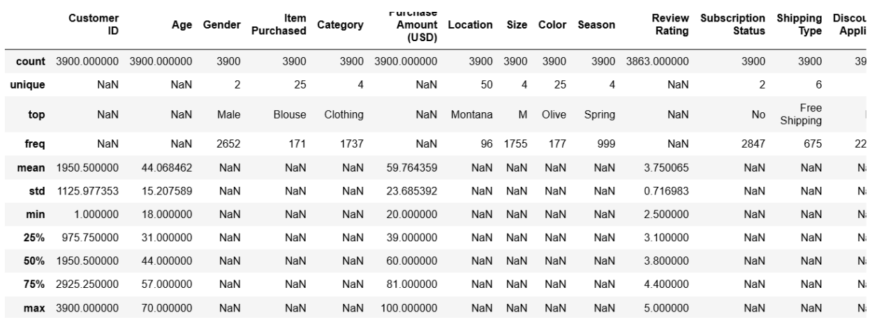

- Handling missing values: Filled in the missing Review Rating values using the median rating within each product category
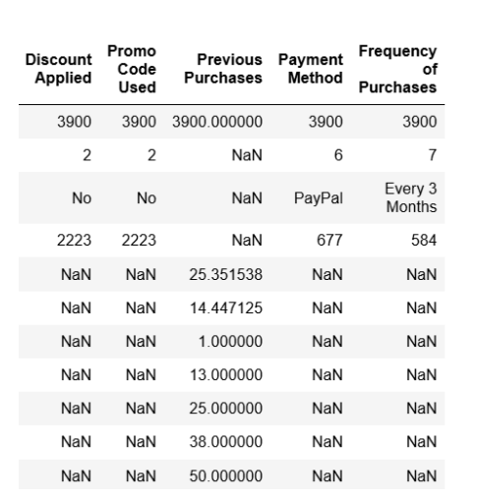
- Column cleanup: Renamed columns to snake_case for clarity and consistency
- Feature engineering:
  - Created an age group column by categorizing customers into age brackets
  - Built a purchase_frequency_days feature from purchase timestamps
- Data consistency checks: Compared discount_applied and promo_code_used and removed redundant promo fields
- Database integration: Loaded the cleaned dataset into PostgreSQL for deeper SQL-based analysis

4. SQL Analysis (PostgreSQL)
We used SQL queries to answer major business questions such as spending trends, product popularity, and the impact of discounts and subscriptions.
1. Revenue by Gender:
Compared total revenue generated by male vs female shoppers.
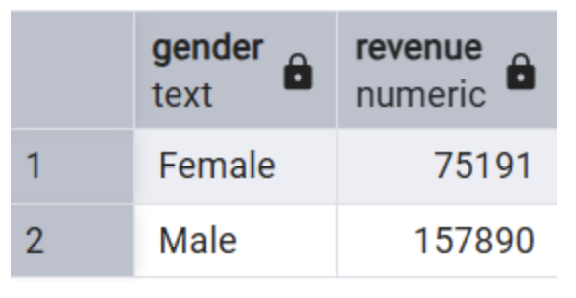

2. High Spending Discount Users:
Identified customers who used discounts but still spent above the average purchase amount.
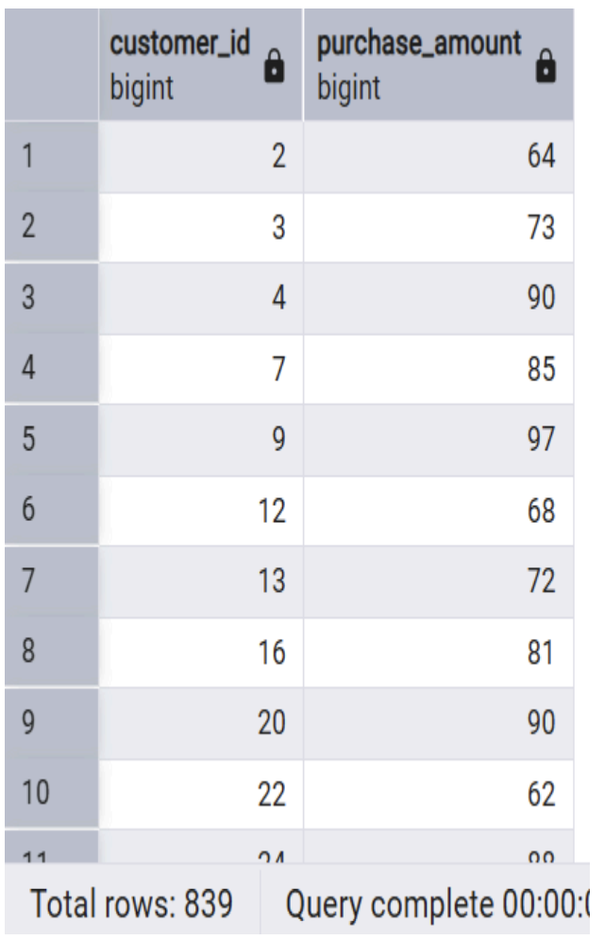

3. Top 5 Products by Rating:
Ranked items with the highest customer review ratings.

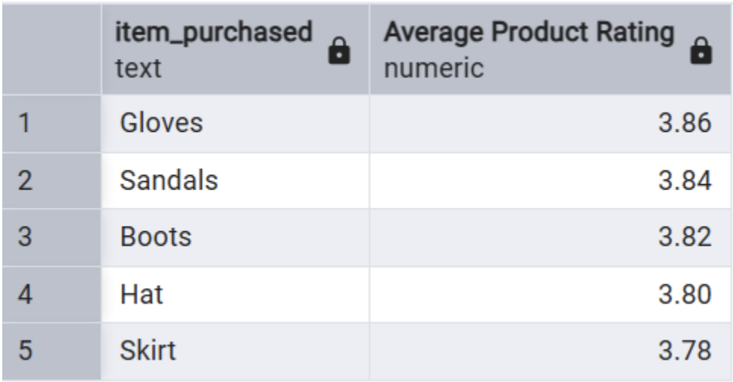

4. Shipping Type Comparison:
Measured how average purchase amounts differ between Standard and Express shipping.
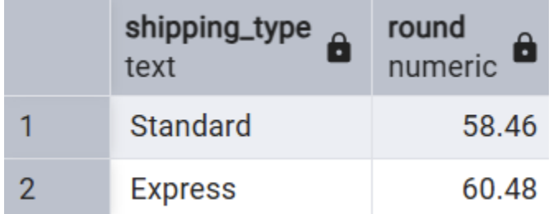

5. Subscribers vs Non-Subscribers:
Compared both average spending and total revenue for subscribers vs non-subscribers.
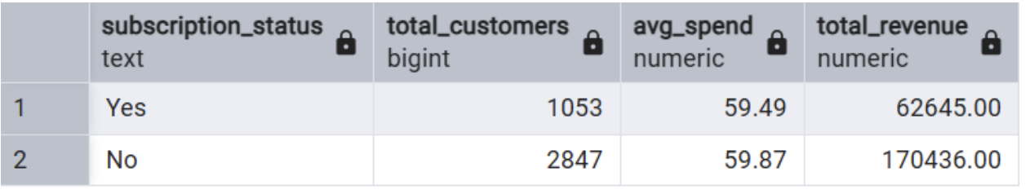
6. Discount-Dependent Products:
Identified which products were most frequently bought with discounts.
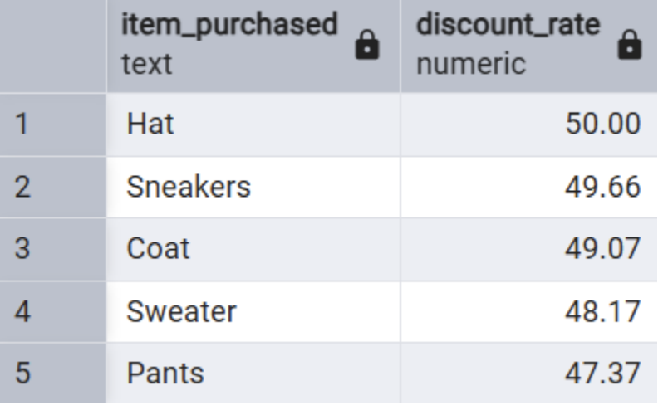

7. Customer Segmentation:
Grouped customers into New, Returning, and Loyal based on their purchase history.
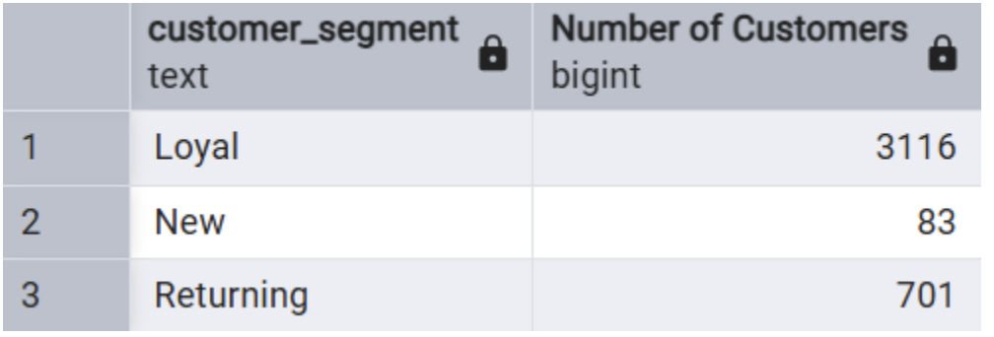
8. Top 3 Products per Category:
Listed the most frequently purchased items within each major category.
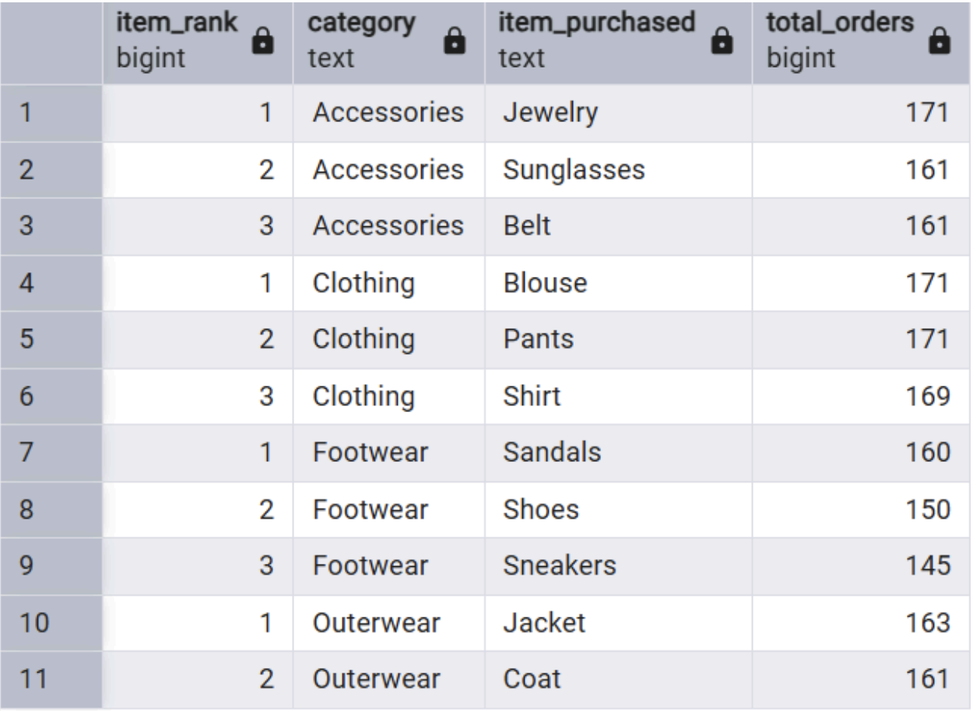

9. Repeat Buyers & Subscriptions
Examined if customers with more than 5 purchases were more likely to have a subscription.
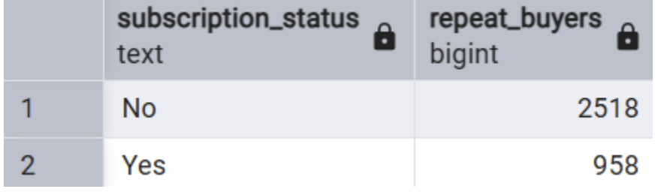

10. Revenue by Age Group
Calculated how much revenue each age group contributed.
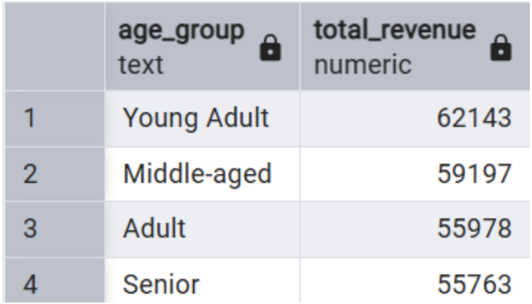

5. Power BI Dashboard
A fully interactive Power BI dashboard was created to visualize all key insights clearly and intuitively. It highlights metrics such as number of customers, average purchase amount, subscription distribution, revenue by category, and age group trends.
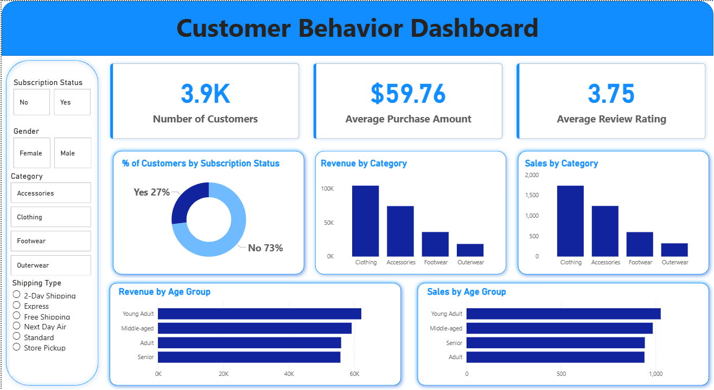

6. Business Recommendations
Based on the combined Python + SQL + Power BI findings, these actionable recommendations were made:
Boost Subscription Sign-ups
Offer exclusive perks and personalized incentives to encourage more customers to subscribe.
Strengthen Loyalty Programs
Reward repeat buyers with points, special offers, or early access to new products.
Reassess Discount Strategy
Balance discount usage to ensure profitability without reducing sales volume.
Improve Product Positioning
Highlight top-rated and bestseller items in marketing campaigns.
Enhance Targeted Marketing Efforts
Focus marketing on:
- High revenue age groups
- Express shipping customers
- shoppers more likely to convert with personalized offers

